Web 2

Introduction
This practical requires us to use the WebSockets API and in order to create server that could display the contents of a directory and traverse through them. Multiple users should be able to connect to the server and view the files without affecting others who are connected.

Usage Instructions
- Navigate to the Web2 folder in terminal and enter the command:
node server.js
- The terminal should then display:
-- server is running: <address:portnumber>
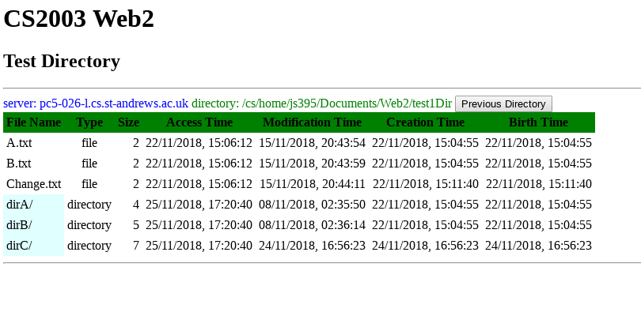
Copy <address:portnumber> and paste it into the address bar of a internet browser of your choice (Mozilla Firefox is ideal). The below directory should be displayed.
- Should you wish to change the directory displayed, simply remove the contents of /Web2/test1Dir and put whatever files you wish to put in instead.
- In order to traverse deeper, click on the directory.
- In order to go to a parent directory press the ‘Previous Directory’ button in the top right.

Summary
Summary of requirements completed:
- Remote directory (the ‘root’ can be viewed, parent directory of said directory cannot be viewed.
- The remote server and directory being accessed are shown in the user interface.
- Clients can navigate into the directory provided and back up to the root.
- Clients can select which details are visible.
- Multiple clients can connect to the server and view the directory and sub-directories without affecting each other.
- The client and server both conform to the specification provided.

Design
The important aspects of designing this practical were deciding what features needed to be on the front-end and what needed to be on the back-end as this is not immediately obvious. My implementation follows this basic structure:
- In my implementation the server gets a directory request from the client and converts the information about files in that directory into a JSON object.
- The server then wraps that JSON object into another in order to comply with the message format protocol and converts the JSON object to a string to transmit.
- The client receives the string from the server and parses it back to JSON
- Then the client converts the JSON to html markup to display on a webpage.
- Steps 1-4 are repeated as new directories are requested by the client.

I chose to give headers to the table provided in dir_list_example.html (renamed to index.html) in order to make the columns easier to navigate. In addition, I changed the CSS to highlight the header when a user hovers over it.

